1. Virus Scan image

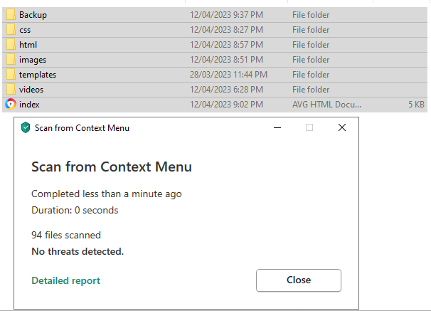

1. Image of the server and my local machine having a backup file:

Server:

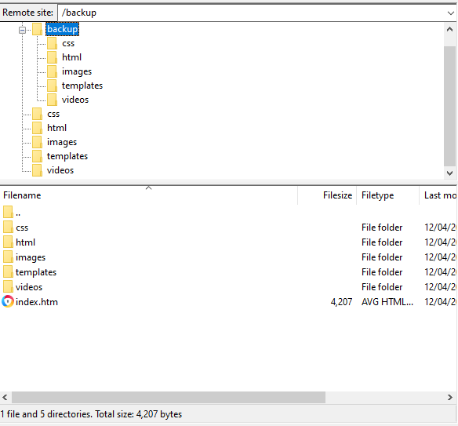

Local Computer:  
 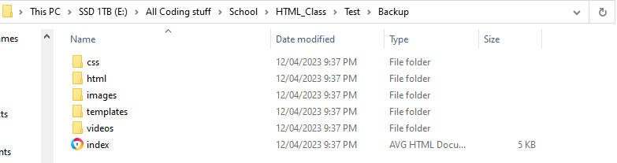

1. Image of file Zilla being used on my local machine to upload my website to the web server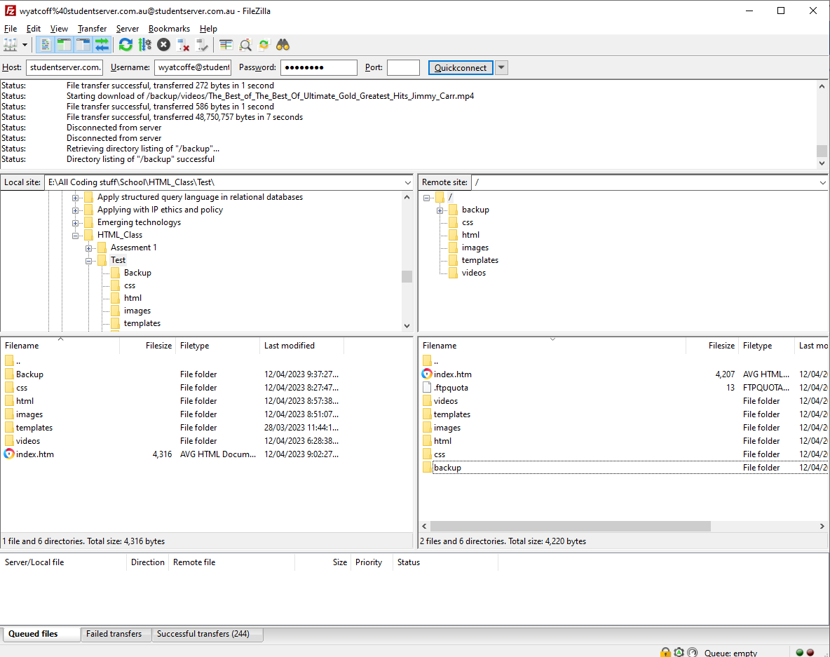
2. Image of the website working on the webserver on both Google Crome and OperaGX

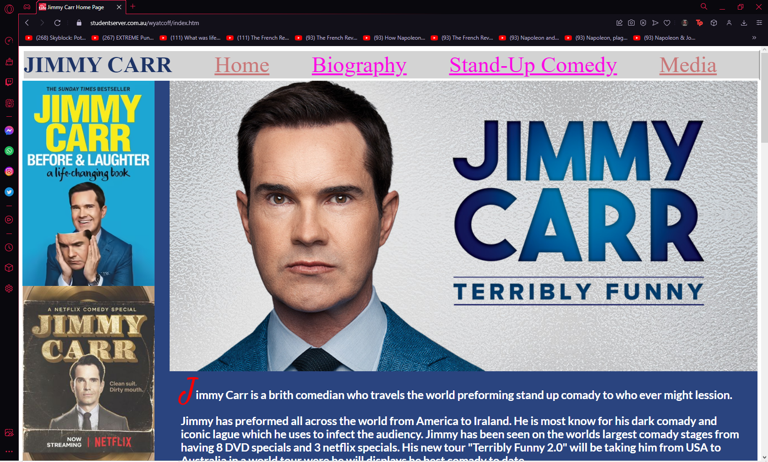

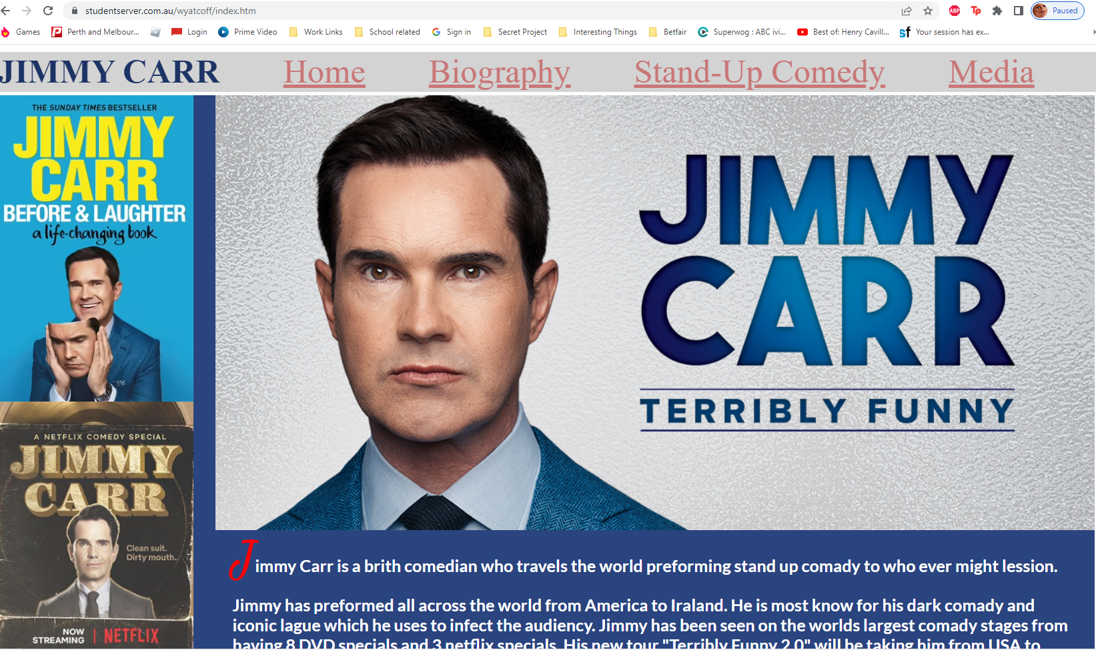

1. My HTML Pages verification

a) Index Page  
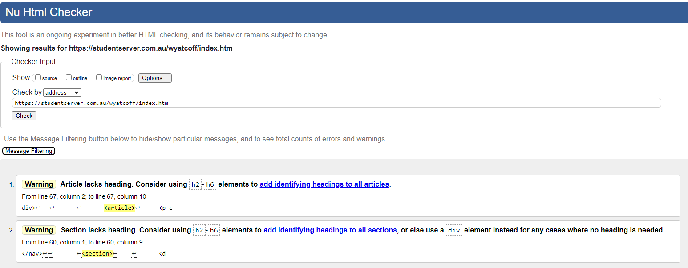

b) Biography Page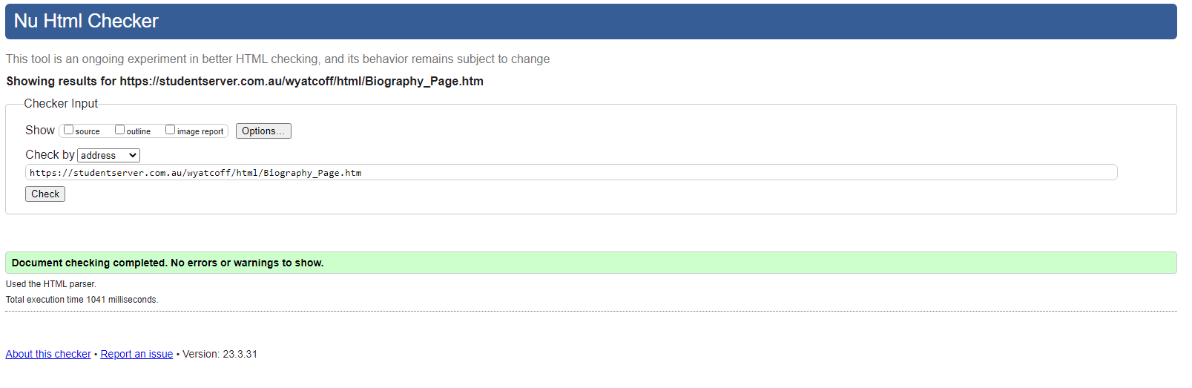 c) Stand-Up Comedy/ Discography page

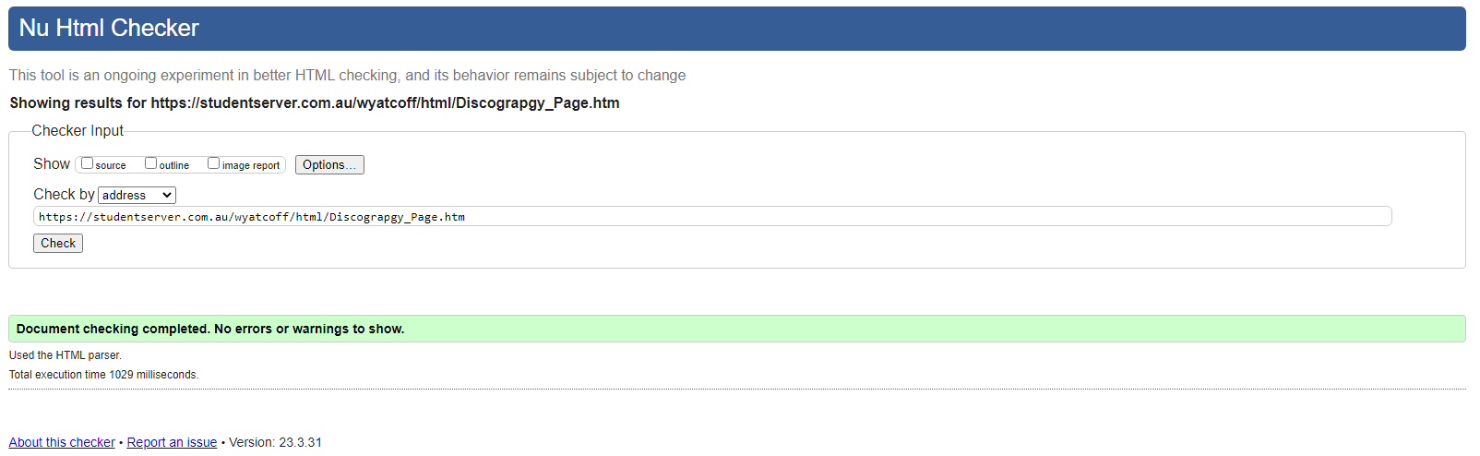

d)Media page

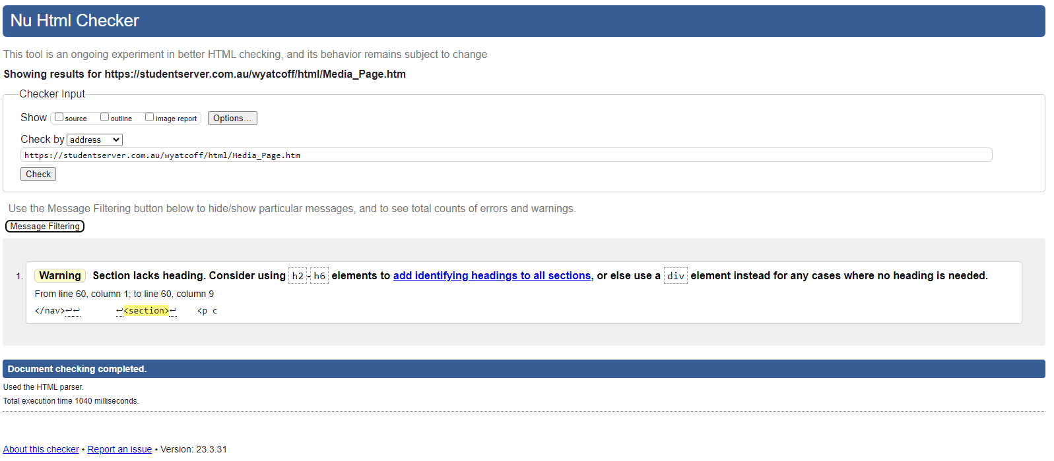

1. My CSS Pages verification

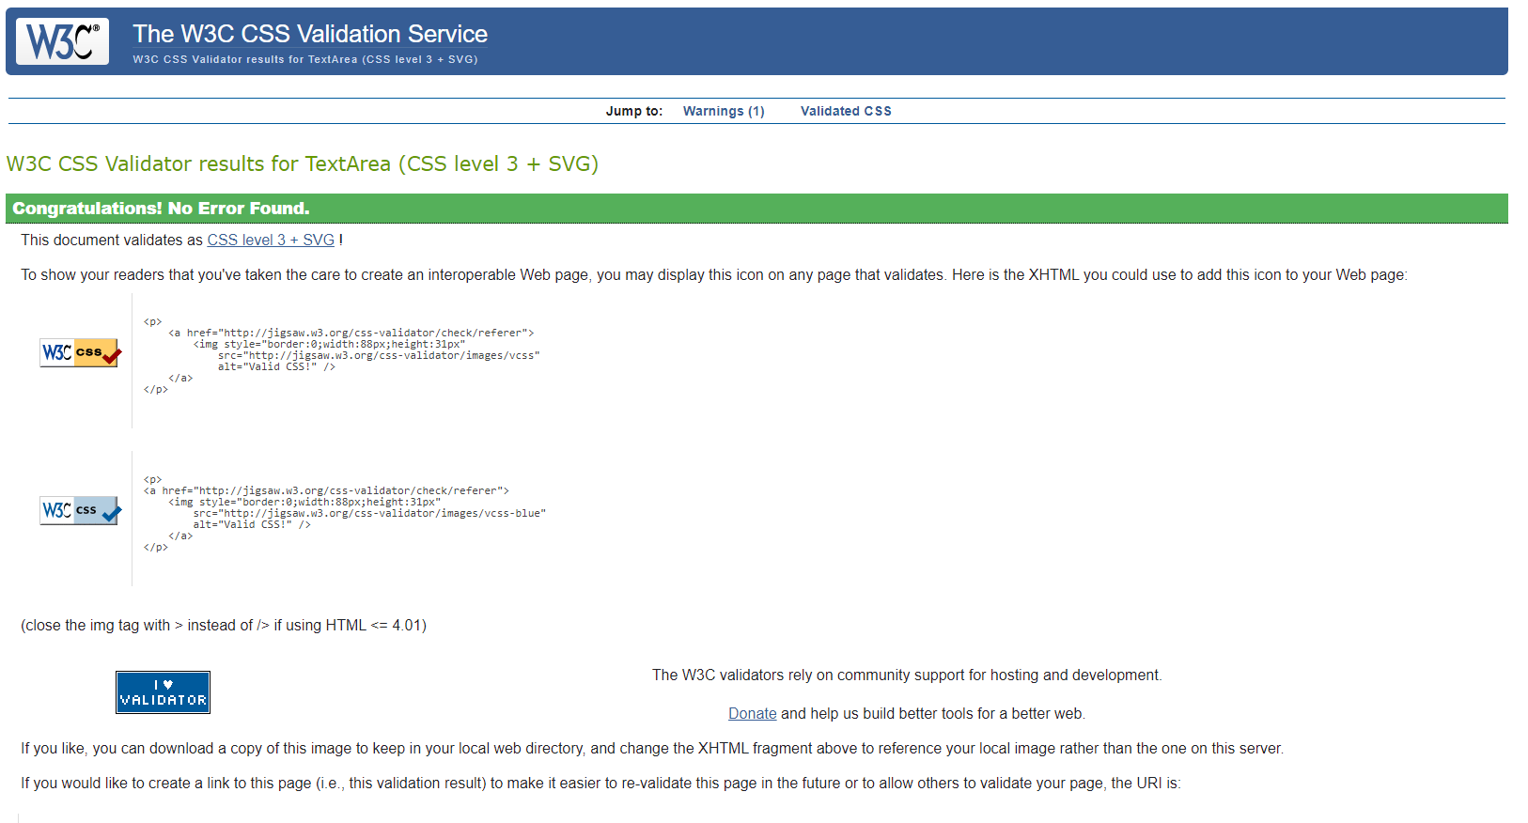

During the building of my website, I tested it both in Google Chrome and OperaGX browsers which both worked faultlessly. To ensure that my final web page would not only work but work well I used the HTML and CSS validation tools made by W3C after each web page was completed. If there were any errors, I would then fix them and rescan my HTML or CSS until there were no errors. My website has been uploaded to the student server through FileZilla, as can be seen in the image below.

